JUNE 2020



**Category Review : Chips**

**Real Analytics**

**Our 17 year history assures best practice in privacy, security and the ethical use of data**



**Privacy Security Ethical Use**

* We have built our Business We are ISO27001 certified Applies to all our facets of our Based on privacy by design internationally recognised for work, from the initiatives we take principles for the past 17 our ability to uphold best on, the information we use and Years practice standards across how our solutions impact our
* Quantium has strict information security, individuals, organizations and Protocols around the We use ‘bank grade’ security society.

Receipt and storage of to store and process data. Personal information Comply with 200+ security

* All information is requirements from NAB, Wool De-identified using -worths and other data

an irreversible tokenisation partners.

Process with no ability to All partner data is held in

re -identify individuals separate restricted environm-

Ents

All access to partner data is Limited to essential staff only Security environment and Processes regularly audited by our data partners

We all have a responsibility to use data for good

Quantium believes in using data for progress, with great care and responsibility. As such please respect the commercial in confidence nature of this document.



* **Task 1**

Here you will include your high level findings and any key callouts for task 1

* **Task 2**

Here you will include your high level findings and any key callouts for task 2



**1**

# Category

**Overview**



Sales have mainly been due to **Budget - older families, Mainstream young singles/couples, and Mainstream - retirees shoppers**. We found that the **high spend in chips for mainstream** young singles/couples and retirees is due to there **being more of them than other buyers**.

## Mainstream, midage and young singles and couples are also more likely to **pay more per packet** of chips. This is indicative of impulse buying behaviour.

We’ve also found that **Mainstream young singles and couples** are **23% more** likely to purchase **Tyrrells chips** compared to the rest of the population. The Category Manager may want to **increase the category’s performance** by **off-locating some Tyrrells** and smaller packs of chips in discretionary space near segments where young singles and couples frequent more often to increase visibility and impulse behaviour.

## Quantium can help the Category Manager with recommendations of where these segments are and further help them with measuring the impact of the changed placement.

**Aﬄuence and its Effect on consumer buying for the category of chips**

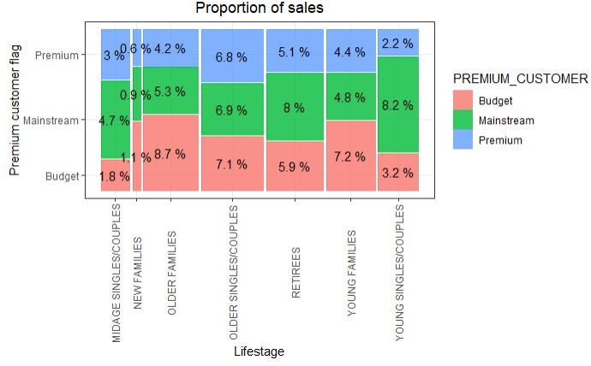

Bar er CCs Cheetcs Cheezels

#### C0bs

##### DOfItO

DOfItOS

French

Crain

IfifUZlOfiS

Infzns Kettle Natural NATURAL

Pringles Red RRD

Smih

Smiths Snbts Sanbites Thins TOttltOS

##### W00lW0rths

A'00LW0RTHS

**Proportion of Customers by Aﬄuence and Life Stage**

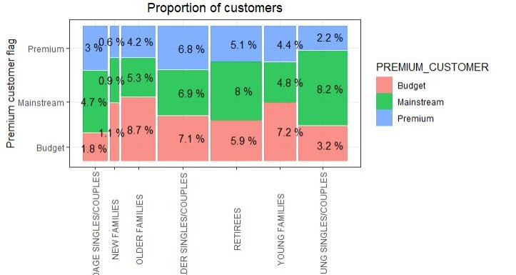

2

# Trial Store Performance

Control Store Vs Other Stores

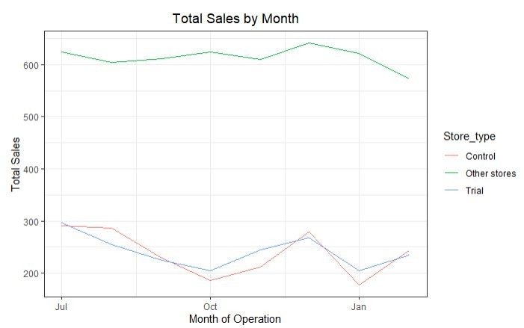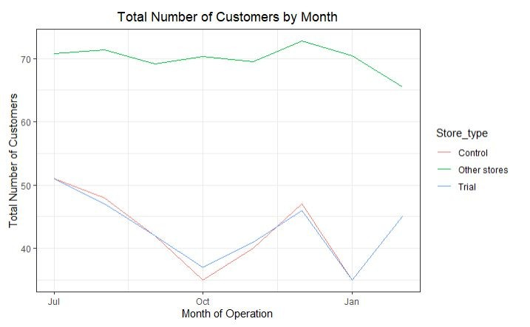

### TOtZI NMIIIkf Of Custon9fS b} flo8tb

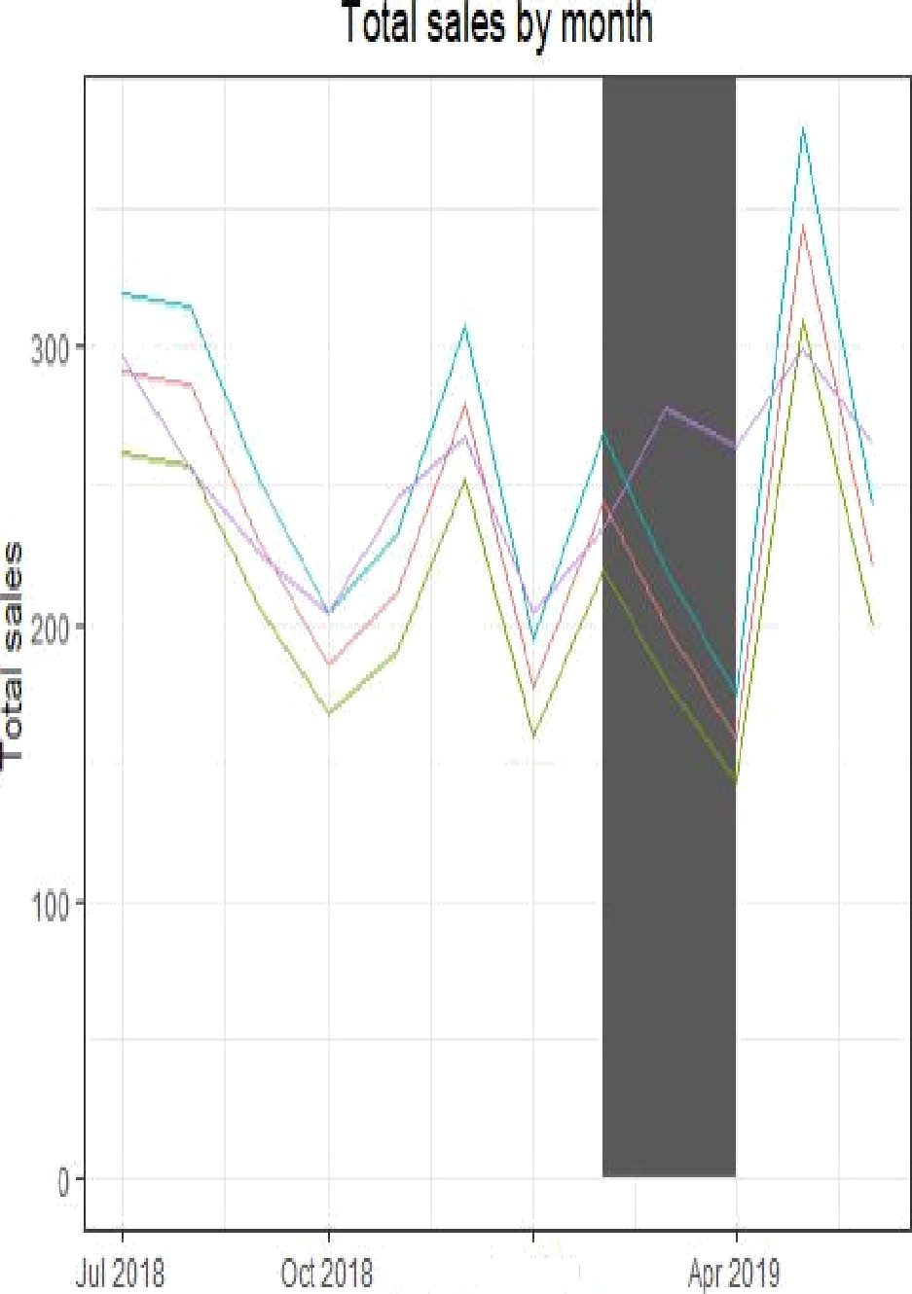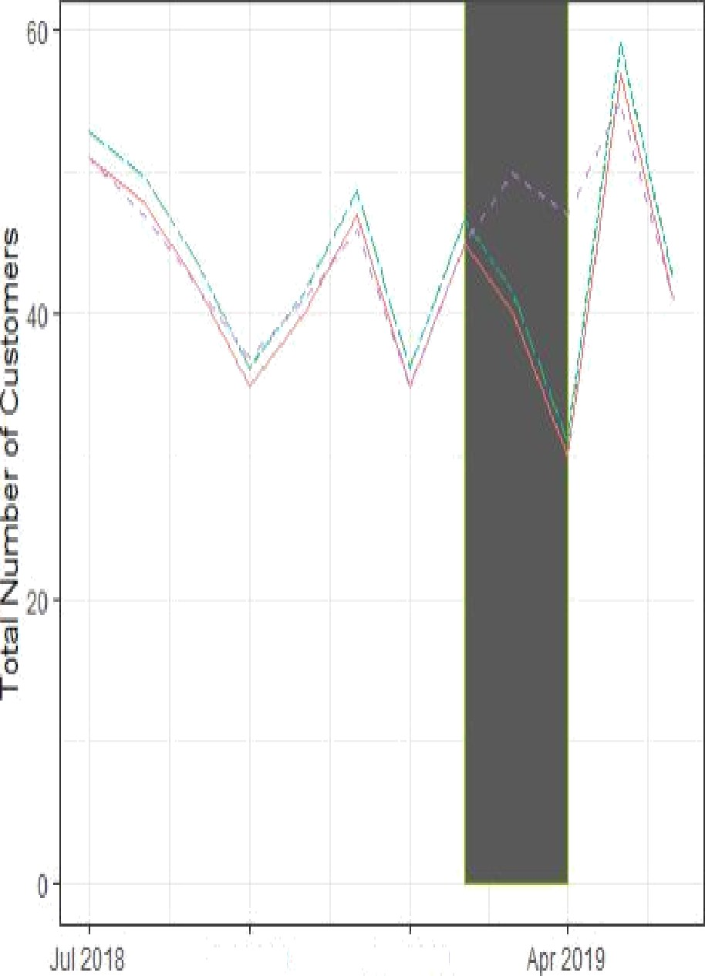







#### — Trial

9Oe#p





- Ttlal

dOH#OiO§O%tBD



quantium